GEN_AI LAB 1
Name: Shivadhanush S
USN: 1RVU23CSE428
Date: 08-04-2026
Generating an email for an event
Tools: ChatGPT
Prompt:
You are the Student Coordinator of RV University Sports Council.
Draft a professional campus-wide email to students announcing the upcoming RV University Inter-School Football Tournament.
The email must include the following clearly labeled sections:
1. Introduction
Briefly explain the importance of inter-school sports events and student participation in football tournaments.
Highlight how such events promote teamwork, fitness, school spirit, and leadership.
2. Event Details
Date of the tournament: (use a placeholder)
Time: (use a placeholder)
Venue: (use a placeholder)
3. Match Day Itinerary
Provide a concise time-wise agenda including:
Team reporting and registration
Opening ceremony
League matches
Semi-final
Final match
Prize distribution
4. Required Instructions
Mention what participants should bring or prepare, such as sports kit, ID card, football studs, water bottle, and team jersey.
Clearly state that students from all schools of RV University are welcome either as participants or audience members.
5. Call to Action
Encourage students to register early and support their school teams.
Include a placeholder for the registration link or coordinator contact details.
6. Closing
Close the email politely and professionally.
Sign off as Student Coordinator, RV University Sports Council.
Tone requirements:
Professional, energetic, and student-friendly.
Suitable for a university-wide announcement.
Concise but informative.
Deliverable:
Subject: RV University Inter-School Football Tournament 2026 - Registration Open
Date: April 8, 2026
To: All Students, RV University
From: Student Coordinator, RV University Sports Council
Dear Students,
Please find below the details of our upcoming RV University Inter-School Football Tournament 2026. We are excited to invite participants and supporters from every school to come together for a day of energy, competition, and campus spirit.
1. Introduction
Inter-school sporting events play an important role in university life by encouraging teamwork, discipline, leadership, and physical fitness. Football, in particular, brings together strategy, coordination, and resilience, making it one of the most engaging team sports on campus. This tournament is designed to strengthen bonds across schools while celebrating talent and sportsmanship at RV University.
2. Event Details
Date: Saturday, April 25, 2026
Time: 8:00 AM - 6:30 PM
Venue: Main Football Ground, RV University Campus
3. Match Day Itinerary
The event will follow the schedule given below:
Time | Agenda Item
8:00 AM | Team reporting, registration, and jersey verification.
8:45 AM | Opening ceremony and welcome address by the Sports Council.
9:15 AM | League stage matches begin across the university football ground.
1:00 PM | Lunch break and team strategy regroup.
2:00 PM | Semi-final matches.
4:30 PM | Championship final match.
5:45 PM | Prize distribution, medals, and best player recognition.
4. Required Instructions
To ensure smooth participation, students are requested to carry the following items:
Valid RV University ID card.
Team jersey and football studs.
Personal water bottle and basic first-aid essentials.
Students from all schools of RV University are welcome, either as registered players or as audience members cheering for their teams.
5. Call to Action
We encourage all interested teams to register at the earliest and make this tournament a memorable celebration of university sportsmanship. Please complete team registration on or before April 18, 2026 using the sports council form below.
Registration Link: https://rvu.example.edu/football2026
6. Closing
Thank you for your enthusiastic support of campus sports. We look forward to seeing all schools come together for an exciting day of football at RV University.
Best Regards,
Shivadhanush S
Student Coordinator
RV University Sports Council

Generating a Brochure for the event
Tools: Canva
Prompt:
Create a dynamic, modern, and professional one-page brochure for a university football tournament titled:
"RV University Inter-School Football Tournament 2026"
Design style requirements:
Energetic, sporty, and youth-focused.
Suitable for a university sports event.
Use a football theme with green field textures, bold action shapes, and balanced university branding colors.
Include clean icons or silhouettes such as football, trophy, whistle, stadium lights, and cheering crowd.
Avoid clutter and keep the layout readable for notice boards and social media sharing.
Content to include (structured clearly):
Header Section
Title: RV University Inter-School Football Tournament 2026
Subtitle: One Campus. Many Teams. One Champion.
Why This Event Matters
Short summary on student engagement, teamwork, and sportsmanship.
Bullet points:
Inter-school team spirit
Leadership and discipline
Fitness and active participation
Event Details
Date: Saturday, April 25, 2026
Time: 8:00 AM - 6:30 PM
Venue: Main Football Ground, RV University Campus
Tournament Highlights (timeline style)
Registration and reporting
Opening ceremony
League matches
Semi-finals
Grand finale
Prize distribution
Who Should Attend
Student football teams from all schools
Faculty mentors and sports coordinators
Students supporting their school teams
What to Bring
College ID card
Team jersey and sports shoes
Water bottle and sports gear
Footer
Organized by: RV University Sports Council
Call-to-action: Register by April 18, 2026
Output expectations:
Portrait layout, A4 poster style.
Readable typography with strong visual hierarchy.
Suitable for digital circulation and campus display boards.
Professional university-event finish.
Output:
Selected Canva poster concept link: https://www.canva.com/d/r7XcaPInq9rc-62
Generated brochure concept summary:
The brochure opens with a bold stadium-style header carrying the title RV University Inter-School Football Tournament 2026 and the subtitle One Campus. Many Teams. One Champion.
A hero visual features a football in motion over a green turf-inspired background with subtle geometric overlays in RV University themed colors.
Event details are displayed in highlighted blocks for date, time, venue, and organizing body so they are easy to read from a distance.
The embedded poster visual below is the final brochure-style output included in this lab record.
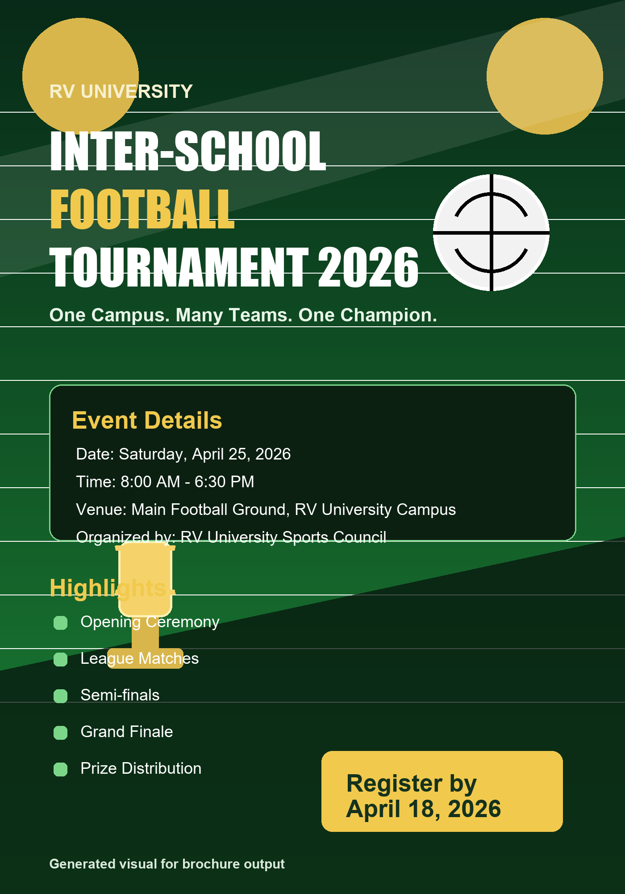
Figure 1: Poster-style image used for brochure output.

Generate a Video about the Event
Tool: Fliki AI
Prompt:
Create a 30-40 second promotional video for a university football tournament.
Style: Energetic, professional, football theme, green and gold sports palette, cinematic but clean motion graphics.
Scene 1
Text: Ready for the biggest football showdown on campus?
Voiceover: "The spirit of competition is returning to RV University."
Visual: Wide stadium shot with students entering the football ground.
Scene 2
Text: Teamwork | Passion | Sportsmanship
Voiceover: "Watch schools come together through teamwork, passion, and sportsmanship."
Visual: Players warming up, crowd cheering, whistle animation.
Scene 3
Text: RV University Inter-School Football Tournament 2026
Voiceover: "Join the RV University Inter-School Football Tournament 2026."
Visual: Trophy reveal with football motion graphics.
Scene 4
Text: League Matches | Semi-finals | Grand Finale
Voiceover: "Experience a full day of league battles, semi-finals, and an exciting grand finale."
Visual: Quick-cut timeline panels with football highlights.
Scene 5
Text: April 25, 2026 | Main Football Ground | Register by April 18
Voiceover: "Register now and cheer for your school at the main football ground."
Visual: Crowd celebration and closing tournament logo.
Output
Selected Canva video-visual concept link: https://www.canva.com/d/FEStChb7tQvyfJF
Generated short video concept:
Duration: 35 seconds.
Opening uses fast-paced campus visuals with a football rolling onto the field and bold title animation.
Middle scenes combine student players, cheering supporters, and schedule highlights to create a strong sense of excitement.
Closing frame displays the event date, venue, and registration reminder with a trophy silhouette and university sports branding.
The embedded visual below is used as the supporting image for the video-generation output section.
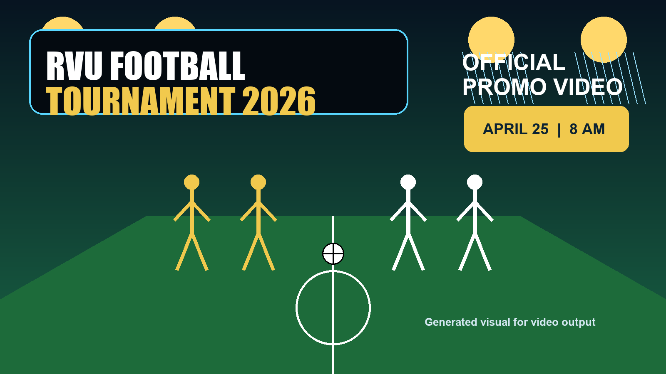
Figure 2: Video-support image used for promo video output.

Narration Prompt:
Create a 2-3 minute university sports explainer video describing the upcoming football tournament at RV University.
Style: Informative, motivational, student-friendly, and visually energetic with sports-themed graphics.
Scene Flow:
Intro
Text: RV University Inter-School Football Tournament 2026
Voiceover: "This video introduces the structure and excitement of the upcoming football tournament at RV University."
Visual: Drone-style campus view transitioning into the football ground.
Why It Matters
Text: Why University Sports Matter
Voiceover: "Sports events build confidence, teamwork, leadership, and a strong sense of belonging across schools."
Visual: Students training and celebrating together.
Tournament Objective
Text: Tournament Objective
Voiceover: "The tournament is designed to encourage healthy competition and showcase football talent across the campus."
Visual: Coaches briefing players and teams assembling.
Agenda Overview
Text: Registration | Opening Ceremony | League Matches | Semi-finals | Final | Prize Distribution
Voiceover: "From morning registration to the final trophy celebration, the event is packed with action throughout the day."
Visual: Animated match-day timeline.
Audience
Text: Who Can Join
Voiceover: "Students from every school can participate, and the entire university community is invited to attend and cheer."
Visual: Mixed crowd of teams, faculty, and supporters.
Preparation
Text: What to Bring
Voiceover: "Carry your ID card, team jersey, football shoes, and water bottle for a smooth match-day experience."
Visual: Sports kit flat lay with icons.
Close
Text: April 25, 2026 | Register by April 18
Voiceover: "We look forward to an unforgettable day of football, sportsmanship, and school pride at RV University."
Visual: Trophy lift and cheering crowd.
Output
Generated narration summary:
The narration begins by welcoming viewers to a university-wide football celebration and explaining the event purpose in a confident and motivating tone.
It then outlines why campus sports matter, describes the tournament flow from registration to finals, and reinforces the values of teamwork and discipline.
The final section invites students to register, attend, and support their school teams, ending with a strong closing line focused on pride, participation, and sportsmanship.

